What is a Package Diagram?
A Package Diagram is a UML structural diagram used to organize, group, and manage related elements (such as classes, interfaces, components, or even other packages) into packages.
It gives a high-level view of system structure and dependencies.
Think of it as a map of your system’s namespaces or modules.

Why Package Diagrams Matter
Package diagrams help to:
- ✅ Manage large and complex systems
- ✅ Show module boundaries
- ✅ Visualize dependencies between subsystems
- ✅ Support clean architecture and layered design
- ✅ Reduce tight coupling
They are especially useful before or alongside class diagrams.
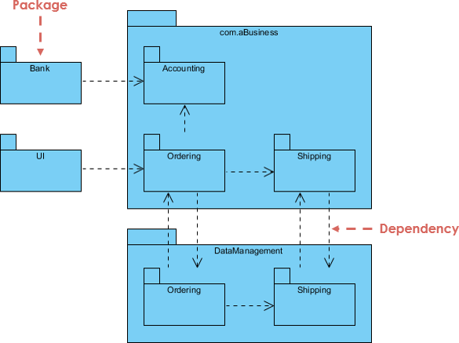
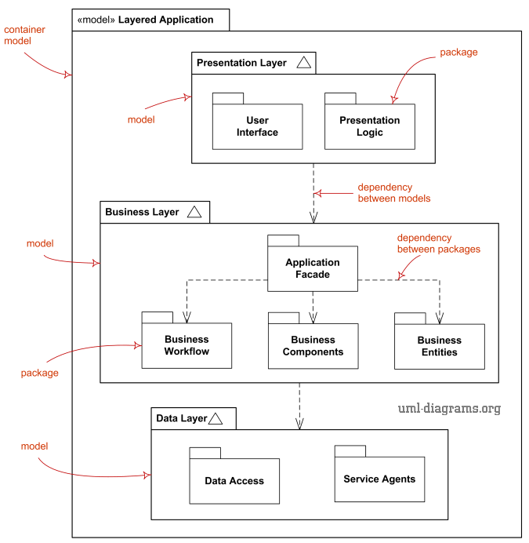

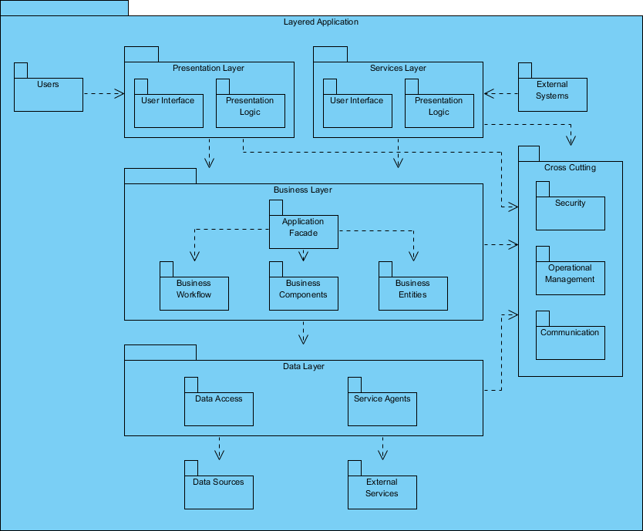

An Object Diagram (UML) is a snapshot of objects at a specific moment in time—showing real instances (with values) and the links between them. It’s like a “photo” of your system while it’s running.
UML Object diagrams are very closely related to class diagrams. While both diagrams afford the user a static, bird’s eye view of a system, object diagrams represent a particular instance of a class diagram at a given point in time. They represent the functionality of a class, and how objects within a class relate to each other.
In a nutshell, class diagrams will show you what the objects in a system consist of and their capabilities. It also offers a static overview of a system. On the other hand, object diagrams show how the objects behave with each other in a given period, providing you with a more detailed, dynamic view of the system.
Here is an example of object diagrams illustrating a company's structure, from which there are mainly two departments - The sales department and the R&D department.
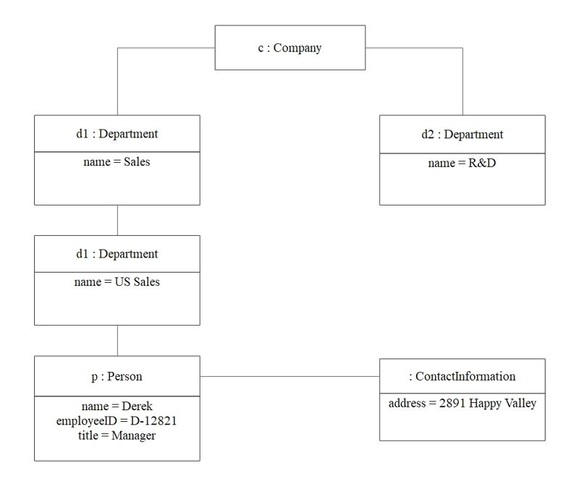
Object Diagram 1: Structure of A Company

The example 2 demonstrate the university course department. For the math statics, it divided by graduate and undergraduate.

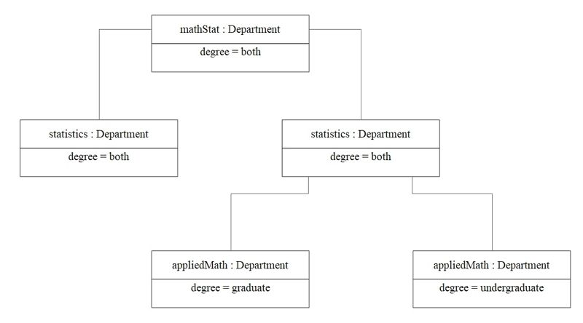
Object Diagram 2: Breakdown of University Course Department
H/Work: Find out about the attributes in the Object Diagrams.

